Test Automation Dashboard Documentation

GithubURL: https://github.com/singhautomation1112/ai-case-study.git
Run the application through Streamlit

Screenshots

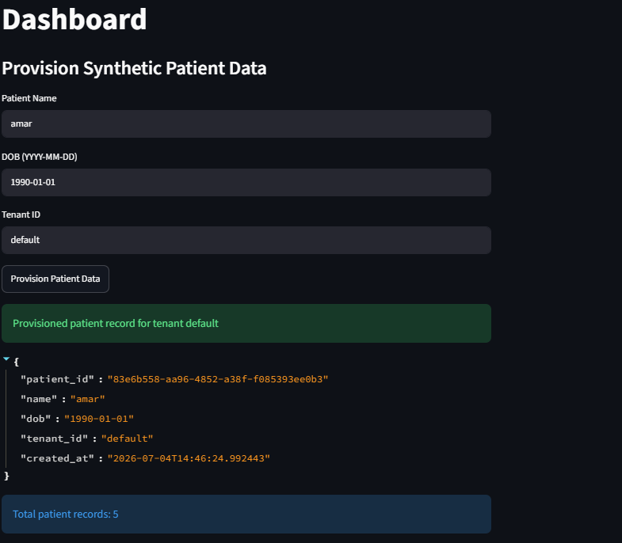

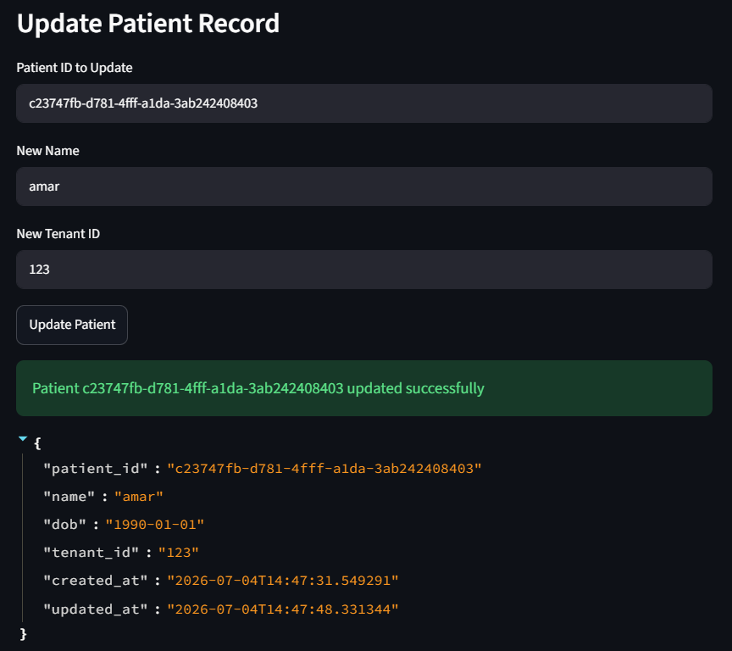

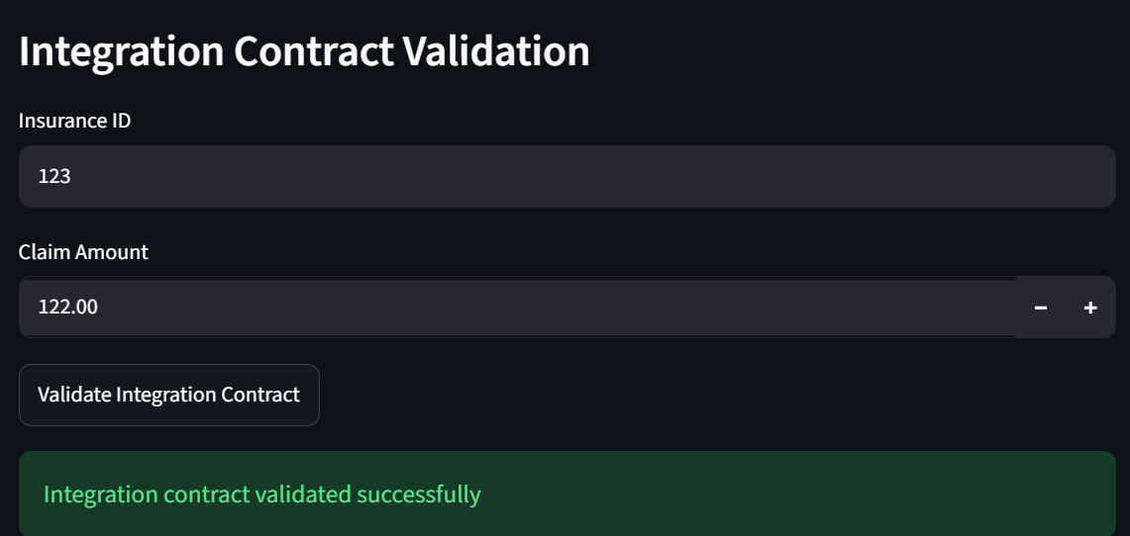

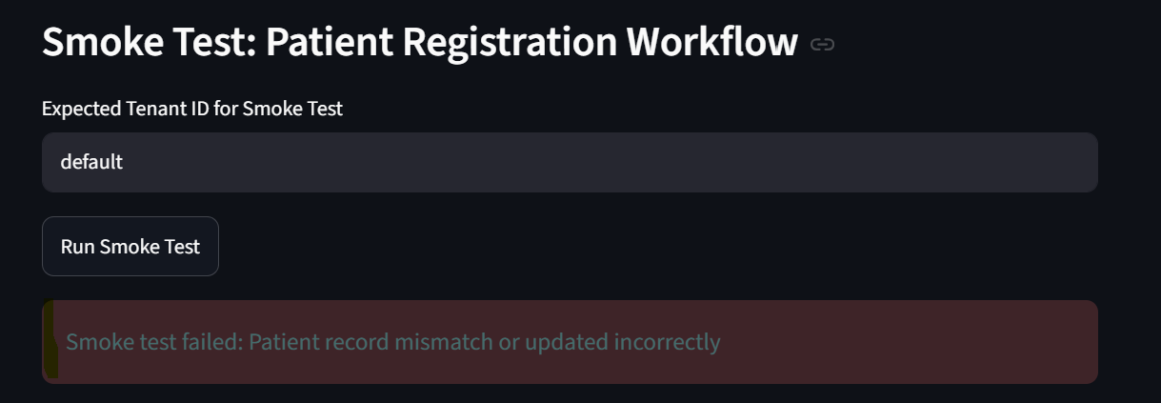
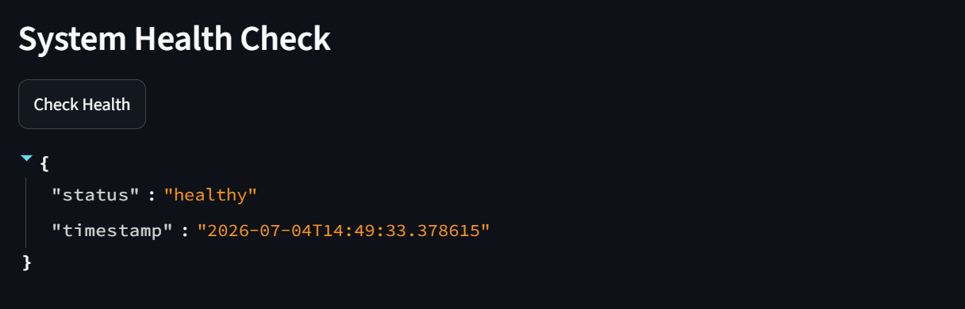
1. Provision Synthetic Patient Data
- What it does:
  - Provides text inputs for patient name, date of birth, and tenant ID.
  - On clicking Provision Patient Data, a synthetic patient record is generated with a unique ID and stored in st.session_state.TEST_DATA_REPO.
  - Displays the record and shows the total patient count.
- Linkage:
  - This is the foundation for all other workflows. Smoke tests and integration validations depend on having patient data available.
- Alignment:
  - Problem Statement: Solves the issue of ad hoc test data by introducing a centralized, synthetic, anonymized repository.
  - Test Strategy: Matches “Centralized Test Data Repository” and “Automated refresh jobs” sections.
2. Update Patient Record
- What it does:
  - Allows you to enter a patient ID and update their name or tenant ID.
  - Updates are stored back in session state, with a timestamp.
- Linkage:
  - Directly tied to the smoke test. If a record is updated incorrectly (e.g., tenant mismatch), the smoke test will fail.
- Alignment:
  - Problem Statement: Simulates data mismatches between modules (e.g., tenant changes).
  - Test Strategy: Implements data reconciliation checks and versioned datasets by validating consistency during smoke tests.
3. Integration Contract Validation
- What it does:
  - Provides inputs for insurance ID and claim amount.
  - On clicking Validate Integration Contract, checks if required fields are present.
  - Returns success or failure messages.
- Linkage:
  - Depends on patient/insurance data provision. Ensures external system payloads are valid before workflows proceed.
- Alignment:
  - Problem Statement: Addresses 50% of production incidents caused by integration failures.
  - Test Strategy: Implements contract testing for external APIs (insurance providers, lab systems).
4. Smoke Test: Patient Registration Workflow
- What it does:
  - Provides an input for expected tenant ID.
  - On clicking Run Smoke Test, checks if patient records exist and match the expected tenant.
  - Fails if no records exist or if records have been updated incorrectly.
- Linkage:
  - Relies on data provision and update workflows.
  - Acts as a safeguard to ensure critical workflows (patient registration) are always validated.
- Alignment:
  - Problem Statement: Tackles inconsistent regression coverage and data mismatches.
  - Test Strategy: Matches “Automate smoke tests for critical patient management workflows” and “Regression suite executed monthly + hotfixes.”
5. System Health Check
- What it does:
  - On clicking Check Health, returns a JSON object with system status and timestamp.
- Linkage:
  - Independent, but provides monitoring hooks for CI/CD pipelines.
- Alignment:
  - Problem Statement: Supports frequent hotfixes by enabling quick validation of system health.
  - Test Strategy: Matches “Unified Quality Dashboard” and “Monitoring KPIs” for governance.
How Components Work Together
- Provision Data → Update Record → Smoke Test → Integration Validation → Health Check
- Each section builds on the previous:
  - Provision data first (foundation).
  - Update records to simulate mismatches.
  - Run smoke tests to validate workflows and detect inconsistencies.
  - Validate integration contracts to ensure external reliability.
  - Use health checks for governance and CI/CD monitoring.
This mirrors the layered automation approach in your strategy:
- Platform services → patient registration smoke test.
- Custom modules → tenant-specific data provisioning and updates.
- Integrations → contract validation.
- Governance → health check + metrics.

